Kafka Components :

* Producer :
* Is a source of data that publishes the message.
* Consumer :
* Is a node which consumes the message.

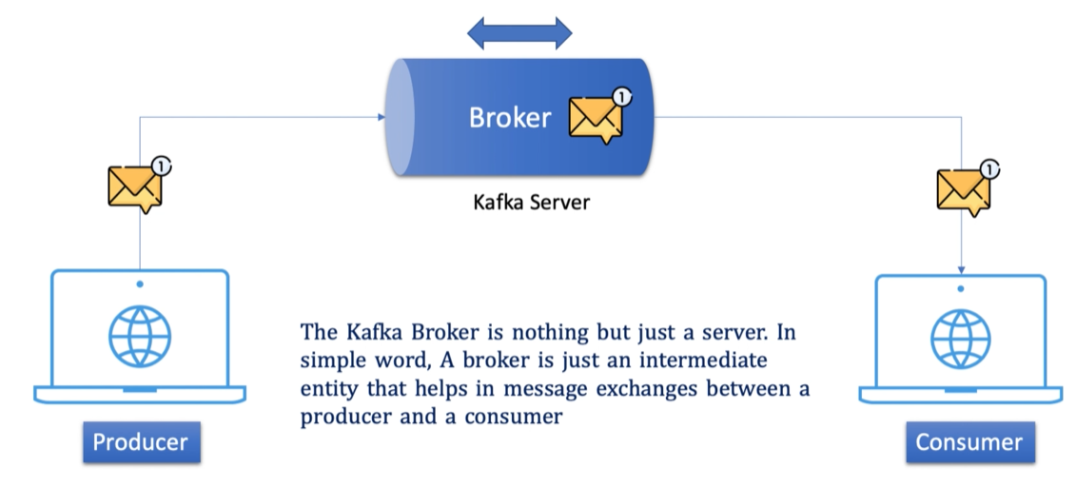

* Broker :
* Is a middleman.
* Cluster :
* Group of servers working for common purpose.

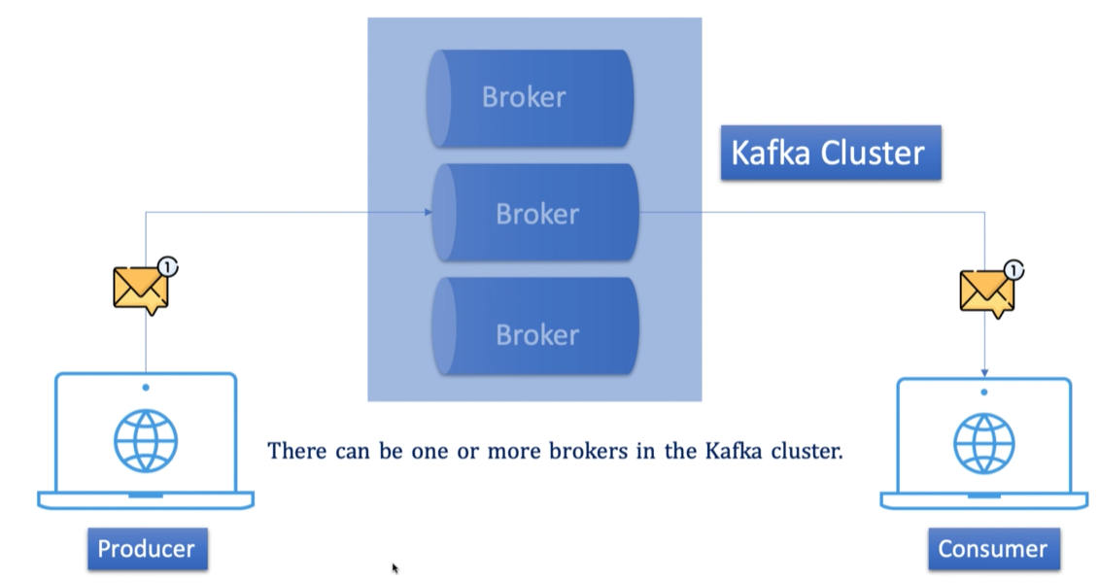

* Topic :

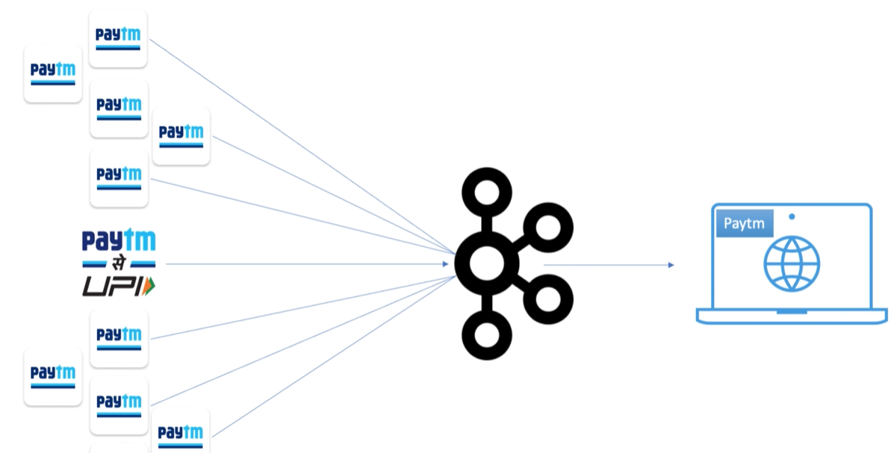

* Multiple types of services.

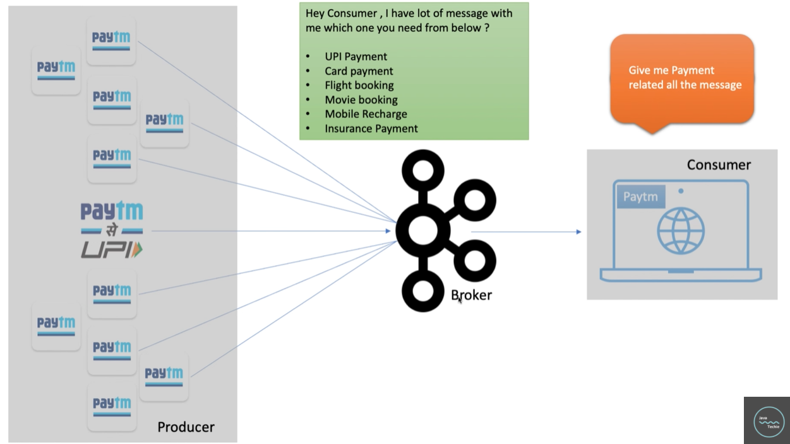

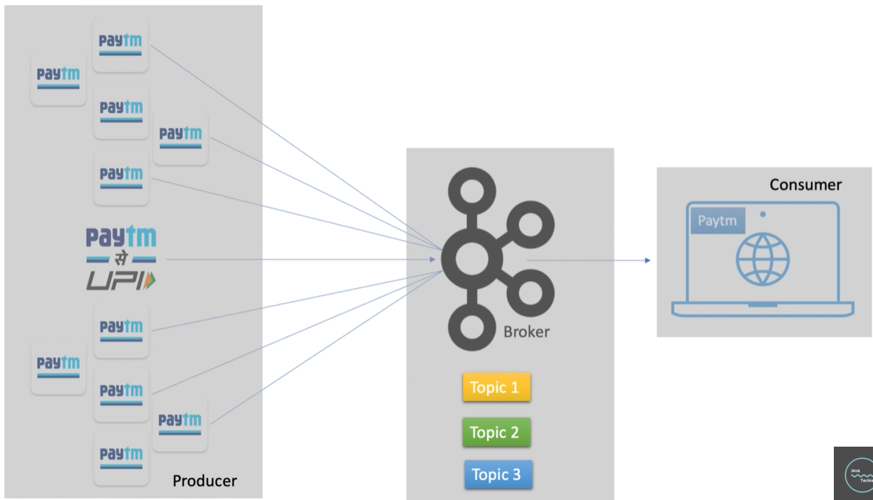

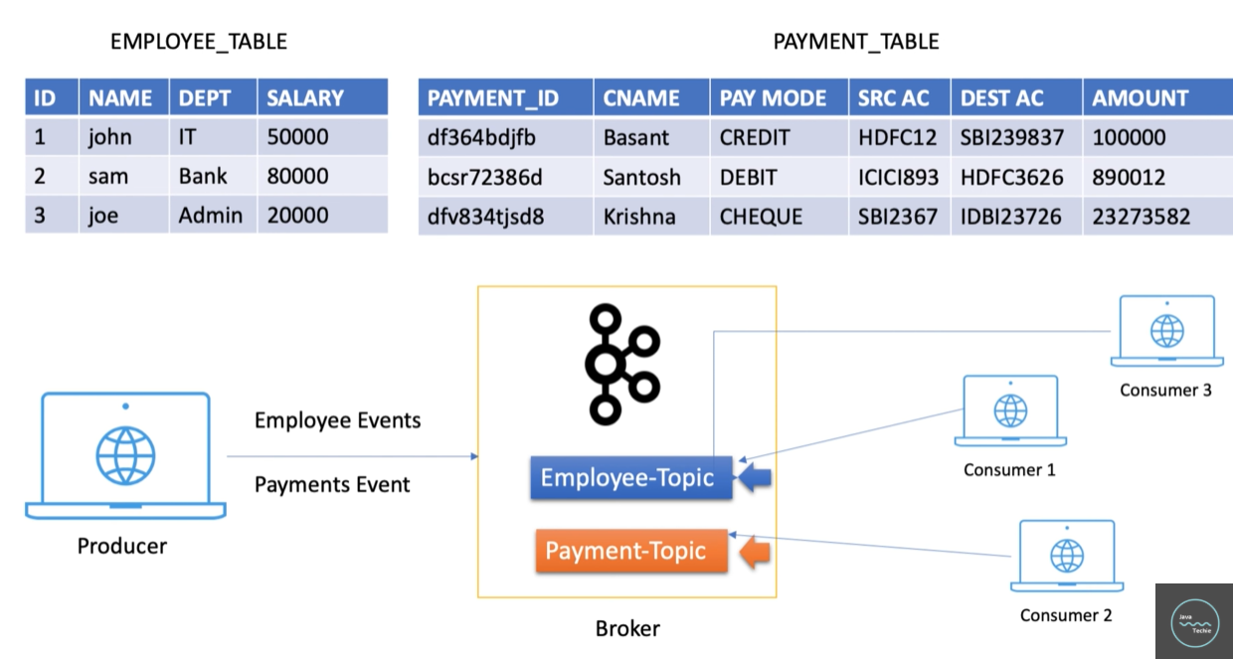

* Topic : If specifies the category of the message or the classification of the message. Listeners can then just respond to the messages that belong to the topics they are listening on.
* Offset :

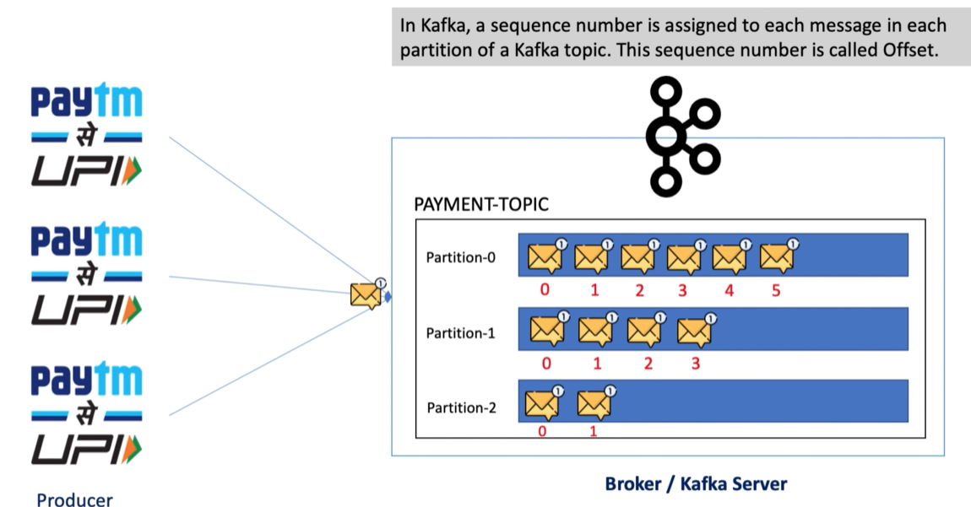

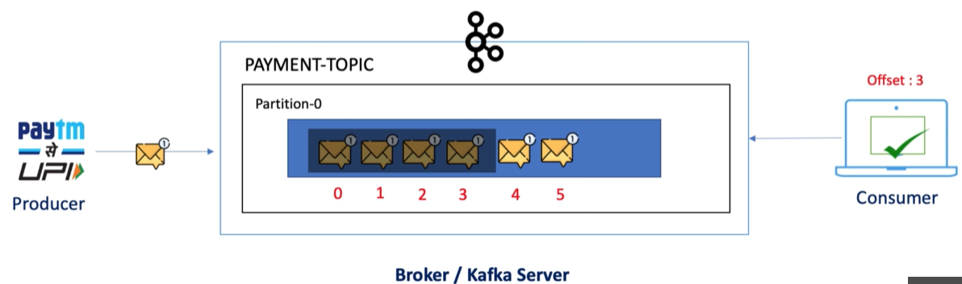

* Zookeeper :
* Zookeeper is a prerequisite for kafka. Kafka is a distributed system, and it uses Zookeeper for coordination and track the status of kafka cluster nodes. It also keeps track of Kafka topics, partitions, offsets, etc.
* It acts as a Manager for the Kafka Cluster.
* It manages the state of all the brokers in the cluster.

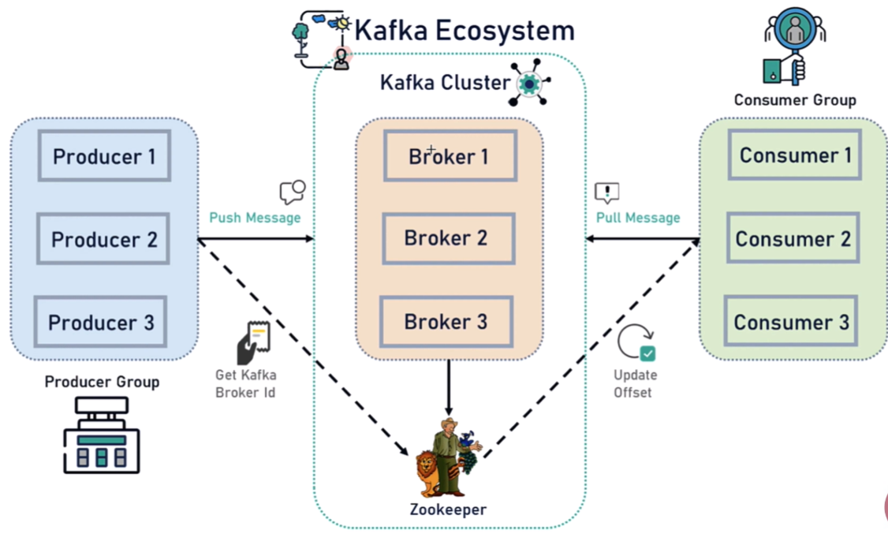

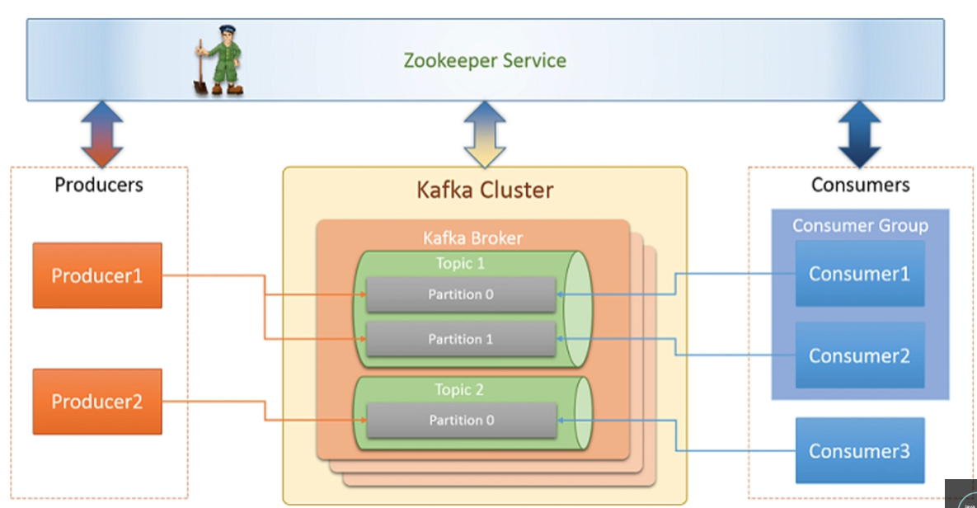

What is Event-driven architecture?

* Event-driven architecture (EDA) is a software design pattern in which decoupled applications can asynchronously publish and subscribe to events via an event broker/message broker.
* In an Event-driven Architecture, applications communicate with each other by sending and/or receiving events or messages.
* Event-driven architecture is often referred to as “asynchronous” communication.
* Event-driven apps can be created in any programming language because event-driven is a programming approach, not a language.
* An event-driven architecture is loosely coupled.

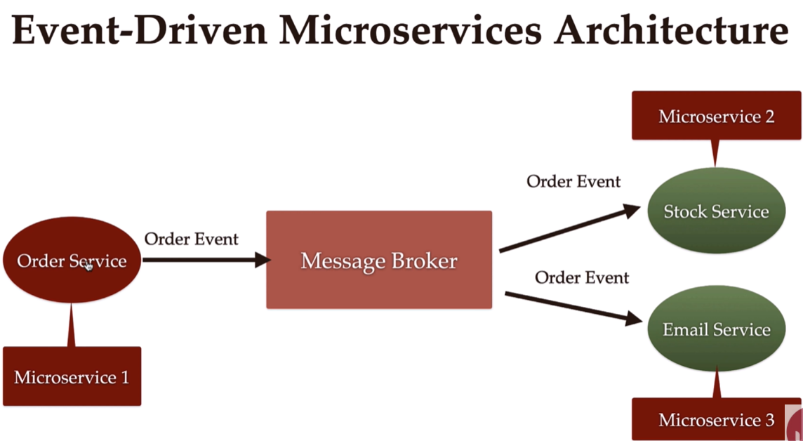

**Kafka Setup :**

**Make sure kafka folder is saved in C drive only!!!**

Step 1 : Extract the kafka archive.

Step 2.1: Configure Environment Variables

Step 2.2: Edit Config Files

* **Zookeeper.properties**

dataDir=/tmp/zookeeper --- > dataDir=C:/kafka_2.12-3.7.0/zookeeper

* **Server.properties**

Log.dirs=/tmp/kafka-logs --- > log.dirs=C:/kafka_2.12-3.7.0/kafka-logs

**Execute all the below commands in the powershell.**

Step 3: Start Zookeeper

Command : .\bin\windows\zookeeper-server-start.bat .\config\zookeeper.properties

Step 4 : Start a Kafka Broker

Command : .\bin\windows\kafka-server-start.bat .\config\server.properties

Step 5 : Checking Kafka Services

Command : jps

